|  |
| --- |
| **Instructions**  Download and extract the files from the **Lab4_starting_code.zip**. Save the files into a folder of your choice – you should obtain several *.py files. Enter your code into the respective *.py file to complete the lab questions. |

**Q1: Number of Days in a Month [ * ]**

Create q1.py and write a piece of Python code that prompts the user for a month number (1 for January, 2 for February, etc.) The program then displays the number of days in that month. You can ignore leap years and assume that February always has 28 days.

You can assume that the user is always going to enter an integer value. If the value is outside of the range between 1 and 12, you should display an error message.

Two sample runs of the code look as follows:

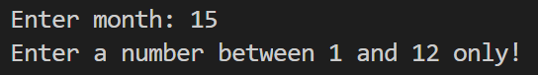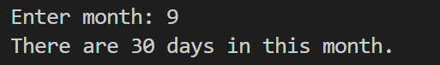

**Q2: Jackpot [ * ]**

You are given a piece of code in q2.py that generates and displays three random numbers between 0 and 9 (both included). This is to simulate a Jackpot machine.

Complete the program to display one of the following messages:

* **"Try again!"** if the three numbers are all different.
* **"Two of a kind!"** if there are two numbers that are the same.
* **"Jackpot!"** if all three numbers are the same.

Three sample runs of the code are shown below:

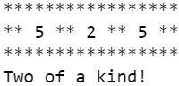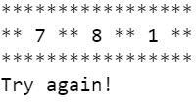

**Q3: Mobile Plans [ ** ]**

A telco company offers the following postpaid mobile plans:

|  |  |  |  |  |
| --- | --- | --- | --- | --- |
| **plan** | **monthly charge** | **outgoing calls (mins)** | **local SMS/MMS** | **local data** |
| **Combo 1** | $25.50 | 80 | 300 | 100MB |
| **Combo 2** | $39.50 | 200 | 500 | 2GB |
| **Combo 3** | $59.50 | 300 | 1000 | 3GB |
| **Combo 4** | $79.50 | 400 | 1500 | 4GB |
| **Combo 5** | $109.50 | 800 | 2000 | 10GB |

Each row shows the monthly charge of each plan and the maximum amount of usage covered by the plan.

Create a new file q3.py, prompt the user for his/her requirements and help him/her find the most cost-effective postpaid plan. The recommended plan should satisfy all his/her needs.

Three sample runs of the program can be found below:

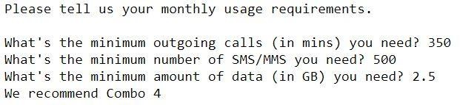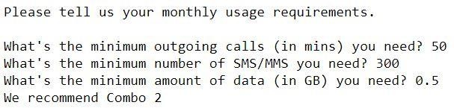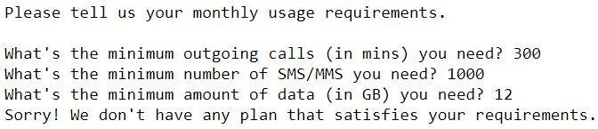

**Q4: Message Encryption**

**Part I [ ** ]**

Create a new file q4.py and write a program that encrypts a message as follows:

* All the occurrences of letter 'a' in the message are replaced by 'e'
* All the occurrences of letter 'e' in the message are replaced by 'i'
* All the occurrences of letter 'i' in the message are replaced by 'o'
* All the occurrences of letter 'o' in the messsge are replaced by 'u'
* All the occurrences of letter 'u' in the messsge are replaced by 'a'

For example, suppose the original message is

This is the original message used.

Then the encrypted message becomes

Thos os thi urogonel missegi asid.

A sample run of the program is shown below:



**Part II [ ** ]**

Can you modify the program above such that the message is not only encrypted as described above but also reversed character by character?

For example, suppose the original message is

This is the original message used.

Then the final output is the following:

.disa igessim lenogoru iht so sohT

A sample run of the modified program is as follows:



**Q5: Message Padding [ *** ]**

1. Create q5.py and define a function called pad_message.

The function takes in two parameters:

* + msg (type: str): This is a string representing a message.
  + width (type: int): This is a number indicating the final length of the returned padded message.

The function **returns** a new string whose length is width, the second parameter. If the original message is shorter than width, then **spaces are padded** to the left of the message. If the original message is longer than width, then the original message is **truncated** on the right hand side to fit into the specified width.

For example,

* + If the message is "IS111 Lab 5", which contains 11 characters, and if the specified width is 20, then this function returns " IS111 Lab 5" (ie. padded with 9 preceding spaces)
  + If the message is the same but the specified width is 8, then this function returns

"IS111 La", which consists of the first 8 characters of the original message.

1. In the same file, add the following codes after your written pad_message function definition:

print(pad_message("IS111 Lab 5", 20))

print(pad_message("IS111 Lab 5", 8))

print(pad_message("hello", 20))

print(pad_message("python programming", 20)) print(pad_message("Hello World! I enjoy programming in Python.",20))

The expected output is as follows:

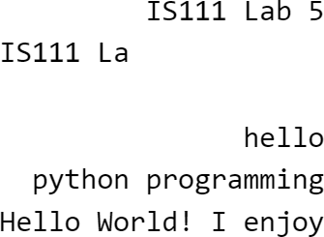

**Q6: Shopping Cart**

**Part A [ ** ]**

Recall that in Lab 2, there was a question related to discounted items. In that exercise, you have implemented the calculate_price_after_discount function. This function has now been provided for you in q6.py.

In q6.py, make use of the function calculate_price_after_discount and write a program that helps a customer check out her items in her shopping cart at a self-checkout counter in a supermarket.

The program first asks the customer how many items the customer wants to check out. The program then prompts the user for the details of each item, including its unit price, its quantity being purchased, whether or not it has a discount, and how much the discount is if there's a discount.

For example, suppose the customer's shopping cart contains the following items:

|  |  |  |  |
| --- | --- | --- | --- |
| **description** | **unit_price** | **quantity** | **discount** |
| **milk** | $5.95 | 2 | 10% |
| **rice** | $6.50 | 1 | 5% |
| **eggs** | $2.40 | 2 | 0% |
| **kaya** | $3.95 | 3 | 15% |

The program shall run as follows:

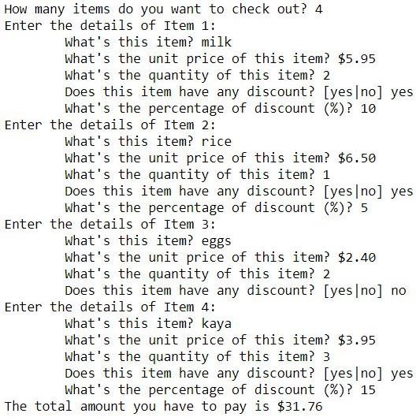

**Note:**

* The shopping cart may change and your program should be able to handle a different shopping cart. i.e., you should not hard code any information such as the number of items, unit prices, quantities, discount rates, etc.
* You may wish to use round(x, 2) to round the number x to contain two decimal places after the decimal point when you display the final total amount.

**Part B [ *** ]**

Copy your Part A code and use it for Part B. Amend it to display the total amount of savings the customer has got, i.e., the difference between the original total price and the total price after discount.

**Note**:

* + You may wish to write a second version of the function we give you earlier (call

it calculate_price_after_discount2) such that it returns both the price after discount and the savings.

A sample run of the modified program can be found below:

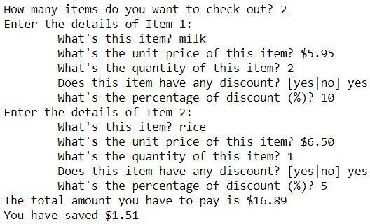

**Q7: Count Words [ ** ]**

In this question we’ll count the number of “a” and “an” in a piece of text.

**Note:** For this question, you are NOT allowed to use the count() method of string. In the file q7.py that has been provided for you, define the following functions:

1. Write a function called count_a that takes in a piece of text (as a string) and returns the number of times the word “a” occurs in the text. You do not need to handle uppercase “A”. You can assume that each time the word “a” occurs, both its previous character and its next character are a space.

For example, count_a("I have a room with a window, a desk and a chair.") should return 4.

1. Write a function called count_an that takes in a piece of text (as a string) and returns the number of times the word “an” occurs in the text. You do not need to handle uppercase “An”. You can assume that each time the word “an” occurs, its previous character and its next character are both a space.

For example, count_an("Every day I have an egg, an apple and a banana for breakfast.") should return 2.

Use the provided count_words_test.py file to test your code. You should not modify

count_words_test.py.

**Q8: Fibonacci Numbers [ *** ]**

Refer to the following link to understand Fibonacci numbers: <https://en.wikipedia.org/wiki/Fibonacci_number>

Essentially, it is a sequence of numbers where each number is equal to the sum of its previous two numbers in the sequence.

Create q8.py and write a function called display_fibonacci(). This function takes in an integer n (greater or equal to 3). It **prints out** the first n Fibonacci numbers, starting from 1. The function doesn’t return anything.

|  |  |  |  |
| --- | --- | --- | --- |
| For example: |  | | |
| display_fibonacci(3) prints out the following output: | 1 | 1 | 2 |
| display_fibonacci(5) prints out the following output: | 1 | 1 | 2 3 5 |
| display_fibonacci(10) prints out the following output: | 1 | 1 | 2 3 5 8 13 21 34 55 |

Use the provided file fibonacci_test.py to test your implemented function. You should not modify fibonacci_test.py.

### Note: In Week 3’s extra in-class exercises we had the same question. However, for this Lab 4, you should use for-loops to solve the problem (and recursive functions are not needed).